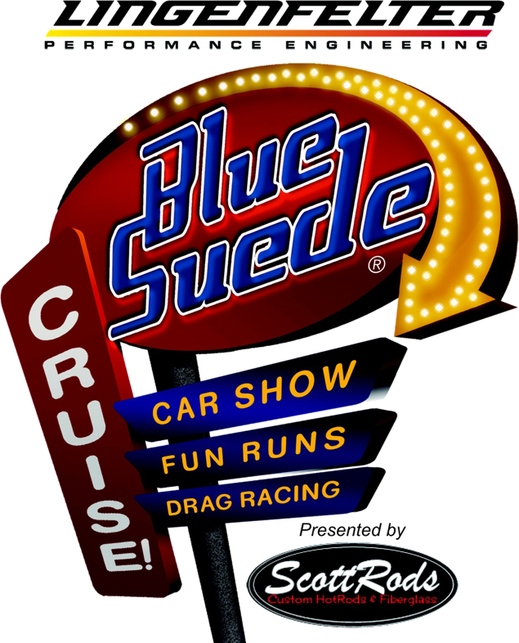
2021 Lingenfelter Performance Blue Suede Cruise Swap Meet Rules

- Vendor’s primary sales are “Used” or “NOS” (New Old Stock) parts only
- Old literature and memorabilia are permitted
- Cars for Sale can also be parked on a Swap Meet space
- No Food or Beverage to be sold in the Swap Meet
- No parts sales permitted from motorhome spaces
- The following items are prohibited as primary product sales in the Swap Meet: Tools, Car Care Products, Lubricants, Specialty Car Products, T-Shirts and Apparel, Hand Crafts, Belts, Die Casts, Sunglasses, etc. If you are interested in selling any of these items at the event email Bobbie Bader at Bobbiebader@summitmotorsportspark.com or call (419)668-5555 ext. 240
- Vendor trucks and / or trailers must fit within the Swap Meet space or be parked at the Trailer drop located in Linder’s Lot
- Additional vehicles can park free in Spectator Parking
- Any Swap Meet vehicles parked on the show field will be towed at the owner’s expense

